GitHub - OnePi-1pi/OnePiTranslator: A simple GUI tool for translating text or documents and rename files or folders name . using both online(deeptranlator) an...

# **OnePi Multi-functional Translator**

## **A simple GUI tool for translating text or documents and renaming files or folder names. Uses online (deeptranslator) and offline (Argos Translate) translation.**

English | [中文](https://github.com/OnePi-1pi/OnePiTranslator/blob/main/README_zh.md)

An integrated GUI program of offline translation Argos Translate and online translation DeepTranslator, which can be used to translate text, documents or batch translate and rename files or folders. Fixed some minor bugs in DeepTranslator and optimized Argos Translate.



# **Table of Contents**

Features Installation Instructions

Video and Documentation Links

**The video** ⬆ **provides more detailed instructions**

## **Features**

**Supports Multiple Languages**

Supported language options include: Simplified Chinese, English, العربية, Français, Español, Português, Deutsch, 한국어, Italiano, 日本語, Русский, Polski, हिनद, Türkçe, ไทย, Traditional Chinese.

**Multiple Translation Engine Integration**

Combines online translation (via DeepTranslator) and offline translation (via Argos Translate), and can store API keys, switching between them with one click as needed.

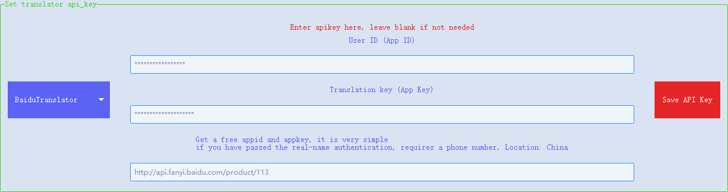

**Batch Translation and Renaming**

Supports batch translation of file names or folder names, which can be manually changed after translation, and original file names can be added, then renamed, with undo operation supported after renaming.

https://github.com/OnePi-1pi/OnePiTranslator[2024/8/21 23:59:22]